PROJECT REPORT
SafeHeader Audit
Automated Web Security Header and CORS Configuration Checker

Student Name | Bhavanasi sreevathsa_ _____________________________
Project name | _SafeHeader Audit: Automated Website Security Header Scanner _________________________
Course / Semester | _cybersecurity/ fifth semester  _______________________________
Institution | Dhanalakshmi Srinivasan university_______________________________
Guide / Faculty | IBM Bharath cares________________________
Date of Submission | _23-10-2026_______________________________

1. Abstract
SafeHeader Audit is a lightweight Python-based website security configuration checker. It examines the initial HTTP response of a supplied website and records selected security headers, basic HTTPS URL usage, HTTP status, and visible CORS response-header configuration. The application generates HTML, JSON, and CSV reports to make observations easy to review and preserve. This project demonstrates HTTP communication, Python programming, basic web-security configuration, error handling, and report generation. It is not a full penetration-testing tool, and all findings require contextual validation.

2. Introduction
Web applications rely on HTTP response headers to communicate security-related browser policies. Examples include Content-Security-Policy, Strict-Transport-Security, X-Content-Type-Options, X-Frame-Options, Referrer-Policy, and Permissions-Policy. Cross-Origin Resource Sharing (CORS) response headers influence whether browser-based code from another origin can read a response. SafeHeader Audit provides a repeatable way to inspect these values.

3. Problem Statement
Manual review of response headers can be inconsistent for beginners. A small tool can collect a standard set of observations and present them in a consistent report. Header presence alone cannot prove that a website is secure, and missing headers do not always imply a vulnerability.

4. Objectives
- • Build a Python tool that requests a user-supplied website URL.
- • Capture HTTP response status and selected response headers.
- • Check HTTPS URL usage.
- • Identify missing selected security headers for further review.
- • Summarize visible CORS configuration.
- • Export results to HTML, JSON, and CSV.
- • Handle malformed URLs and common connection failures gracefully.
- • Encourage authorized, ethical security testing.

5. Scope
The project checks the first HTTP response reached from the supplied URL. It does not crawl pages, test login flows, perform active exploitation, assess application logic, validate all TLS settings, or guarantee detection of vulnerabilities. It is suitable for a small educational demonstration and can be extended later.

6. Tools and Technologies
Programming language: Python 3.
Core libraries: urllib, ssl, socket, csv, json, html, pathlib, argparse, datetime.
Editor: Visual Studio Code or any text editor.
Operating system: Windows, Linux, or macOS with Python installed.
External dependencies: None.

7. System Requirements
Hardware: A basic laptop or desktop with network access.
Software: Python 3.10 or later recommended, a terminal or command prompt, and a browser to view the HTML report.
Network: Internet access for the chosen authorized target. Connection failures are reported if the site cannot be reached.

8. System Design and Methodology
Workflow:
1. User enters an authorized URL.
2. Validate and normalize the URL.
3. Send one HTTP GET request with a timeout.
4. Capture status, final URL, and response headers.
5. Check HTTPS usage, selected security headers, and CORS headers.
6. Create findings and remediation suggestions.
7. Export HTML, JSON, and CSV reports.

9. Implementation
The application is implemented in app.py. The normalize_url function checks the input scheme and hostname. The fetch_response function sends a GET request and handles HTTP error responses as responses with useful status/header information. The audit function collects response data and creates findings. Reporting functions export the findings to HTML, JSON, and CSV. The application uses the Python standard library, so no third-party installation is required.

10. Security Checks
- • HTTPS URL usage: notes whether the supplied URL uses HTTPS; this is not a complete TLS assessment.
- • Content-Security-Policy: checks whether a CSP header is present.
- • Strict-Transport-Security: checks whether HSTS is present.
- • X-Content-Type-Options: checks whether the header is present.
- • X-Frame-Options: checks whether the header is present.
- • Referrer-Policy: checks whether the header is present.
- • Permissions-Policy: checks whether the header is present.
- • CORS: records Access-Control-Allow-Origin and Access-Control-Allow-Credentials and flags combinations that warrant review.
Severity labels are guidance for prioritizing review, not proof that a vulnerability can be exploited.

11. How to Execute
Windows:
1. Extract the project ZIP.
2. Open the folder in VS Code or Command Prompt.
3. Run: python app.py https://example.com
4. Replace the example with a website you own or are authorized to assess.
5. Open the generated HTML report in the reports folder.
If needed, use: py app.py https://example.com
Linux/macOS: python3 app.py https://example.com

12. Test Plan
Test 1 — Valid reachable HTTPS URL: expected to capture a response status and produce three report files.
Test 2 — URL without scheme: expected to default to HTTPS.
Test 3 — Invalid URL text: expected to show a validation error.
Test 4 — Unreachable host: expected to record a connection error and still produce reports.
Test 5 — Site with selected headers: expected to mark observed headers as present.
Test 6 — Site without selected headers: expected to record missing-header findings.
Test 7 — CORS wildcard response: expected to describe the observed wildcard and recommend review; wildcard alone is not automatically a vulnerability.
Actual results and screenshots must be added after running the project. Do not claim that a test passed until it has been executed.

13. Results
The SafeHeader Audit tool was executed successfully against https://example.com. The server returned HTTP status 200, and the tool recorded 8 findings for review. The tool generated HTML, JSON, and CSV reports. The findings are configuration observations and do not necessarily indicate confirmed vulnerabilities.
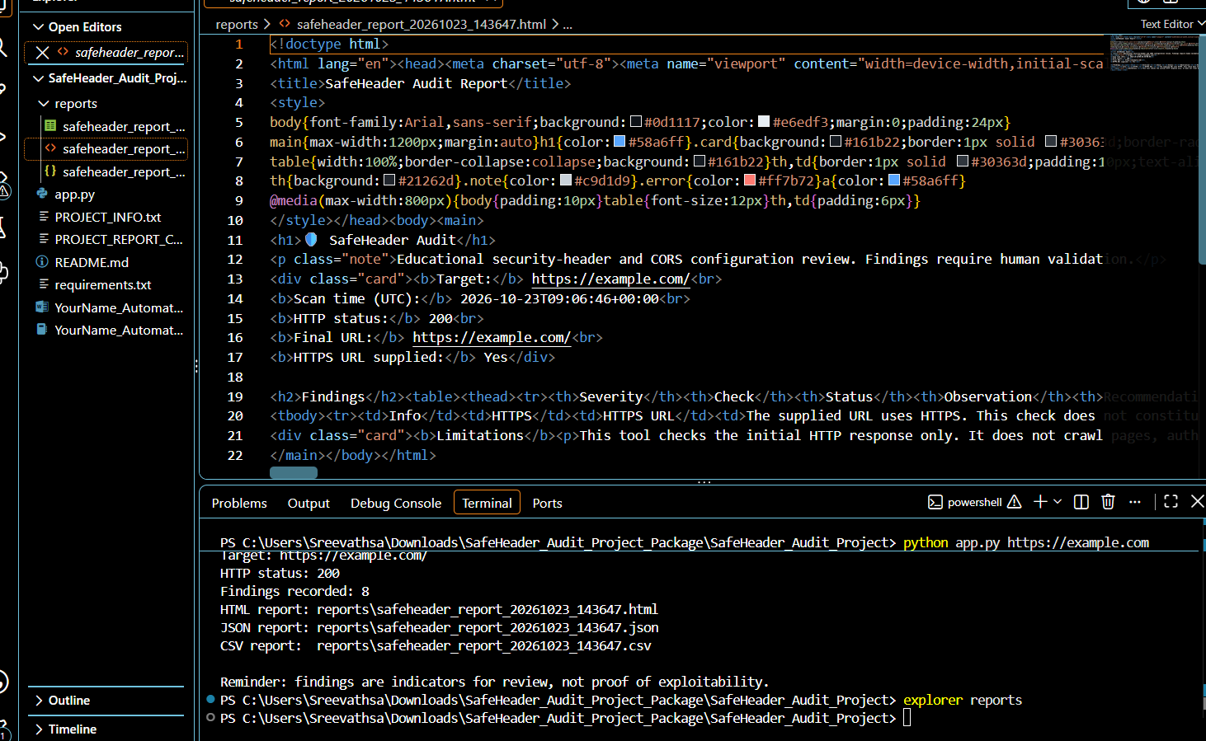

14. Limitations
- • Only the initial response is checked.
- • No site crawling or authenticated scanning.
- • No active exploitation or intrusive testing.
- • No comprehensive TLS audit.
- • Server responses can vary by route, user agent, geography, and time.
- • Missing headers may be intentional depending on the application.
- • CORS interpretation depends on application context and browser behavior.

15. Future Enhancements
- • Add a graphical dashboard.
- • Add automated unit tests.
- • Add configurable severity rules.
- • Support a list of authorized URLs with rate limits.
- • Integrate an OWASP ZAP baseline scan in a controlled, authorized environment.
- • Add remediation tracking.

16. Conclusion
SafeHeader Audit demonstrates how Python can automate a basic review of selected website response headers and visible CORS configuration. It generates structured reports and provides recommendations for manual validation. The tool is intentionally limited and should be treated as an educational configuration checker rather than proof that a website is secure or insecure.

17. References
Python documentation, urllib request and error handling: https://docs.python.org/3/howto/urllib2.html
OWASP ZAP documentation: https://www.zaproxy.org/docs/
OWASP ZAP Baseline Scan: https://www.zaproxy.org/docs/docker/baseline-scan/

Appendix A — Submission Checklist
- app.py included
- requirements.txt included
- README.md included
- Project report saved as .docx
- Actual screenshots added
- HTML/JSON/CSV reports retained as evidence
- Files named according to the IBM submission instructions

